**Lesson 03 Lesson-End Project**

**Scaling of EBS Volume for a Linux VM**

**Project agenda:** Perform vertical scaling of EBS volume for a Linux VM

**Description:** Your company is experiencing business growth where solution deployment is happening with limited resources. In this case, the vertical scalability feature of AWS can be used to create a cost-optimised architecture.

**Tools required:** AWS account

**Prerequisites:** A running EC2 Instance

**Expected deliverables:** EBS volume storage using EC2 Instance

Steps to be followed:

1. Create an EC2 Instance
2. Identify the EBS volume
3. Create a snapshot
4. Create a new volume
5. Detach the existing volume from the EC2 Instance
6. Attach a new volume to the EC2 Instance

**Step 1:** **Create an EC2 Instance**

1. Navigate to the AWS Management Console and search for and click on **EC2**

1. Click on **Instances** and then on **Launch instances**

1. Enter a name for the **Instance**

1. Select **Amazon Linux** **VM** andselect AMI as **Kernel 5.10, SSD**

1. Click on **Create new key pair**

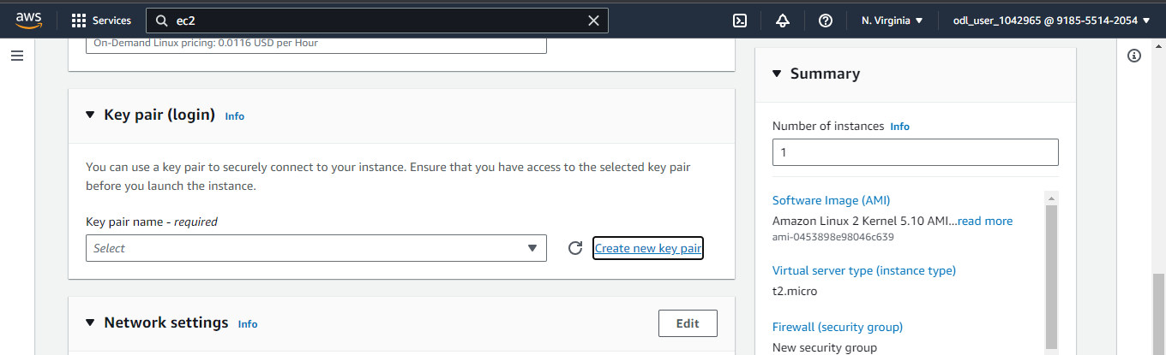

1. Enter the **Key pair name** as **ebs** and click the **Create key pair** button

1. In the **Network settings**, add **Subnet** Availability Zone and click the **Launch** **instance** button

**Note:** We can use the Subnet Availability Zone as **us-east-1a** as well.

The EC2 Instance has been successfully initiated.

**Step 2:** **Identify the EBS volume**

1. Navigate to the **Elastic Block Store** and click on **Volumes**

1. Click on the **Edit** icon, change the name to **old volume**, and click on **Save**

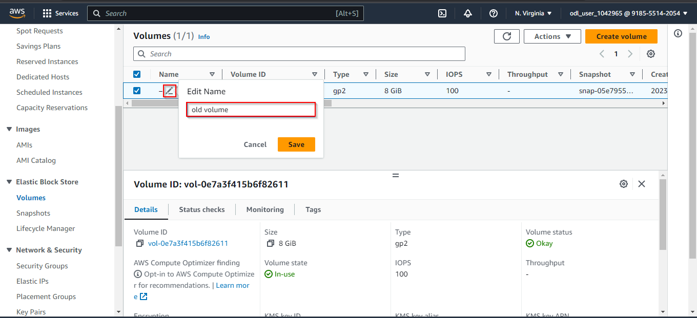

**Step 3:** **Create a snapshot**

1. **Create a** **snapshot** by clicking on the **Actions tab** of the **old volume**

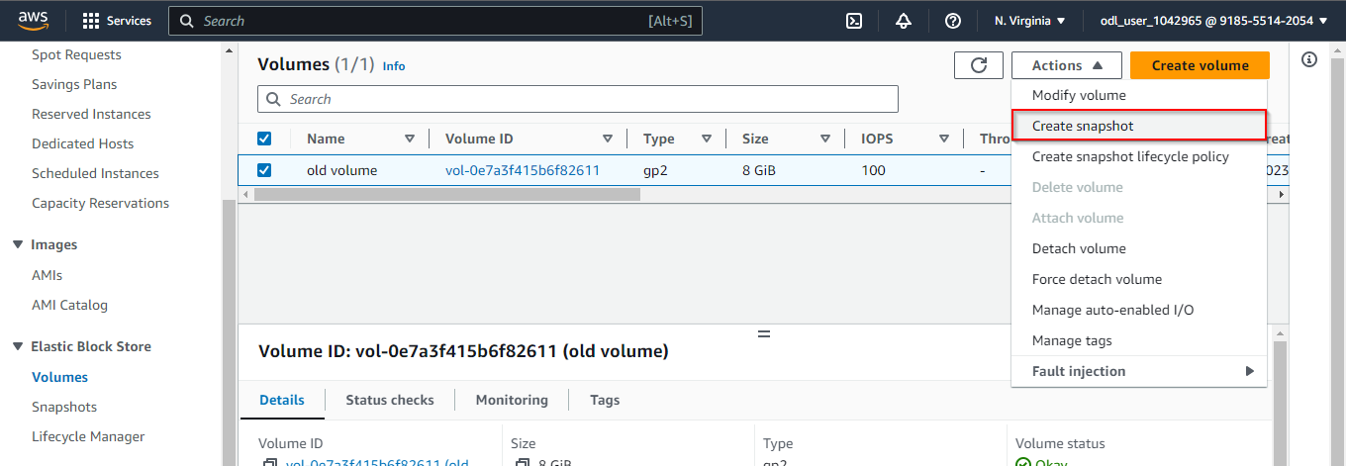

1. Enter a description and click on **Create snapshot**

The snapshot has been successfully created.

**Step 4:** **Create a new volume**

1. Click on **Create volume**

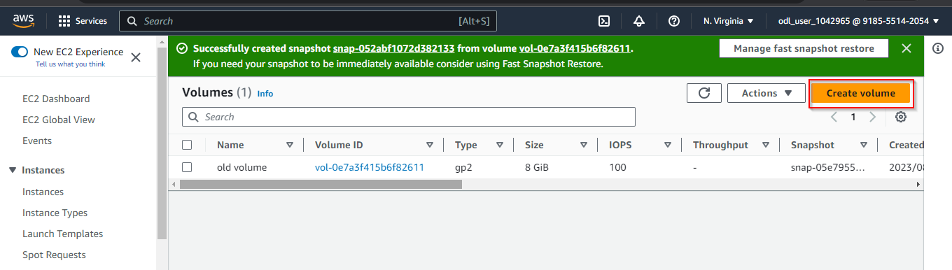

1. Enter the **Size (GiB)** as **13**

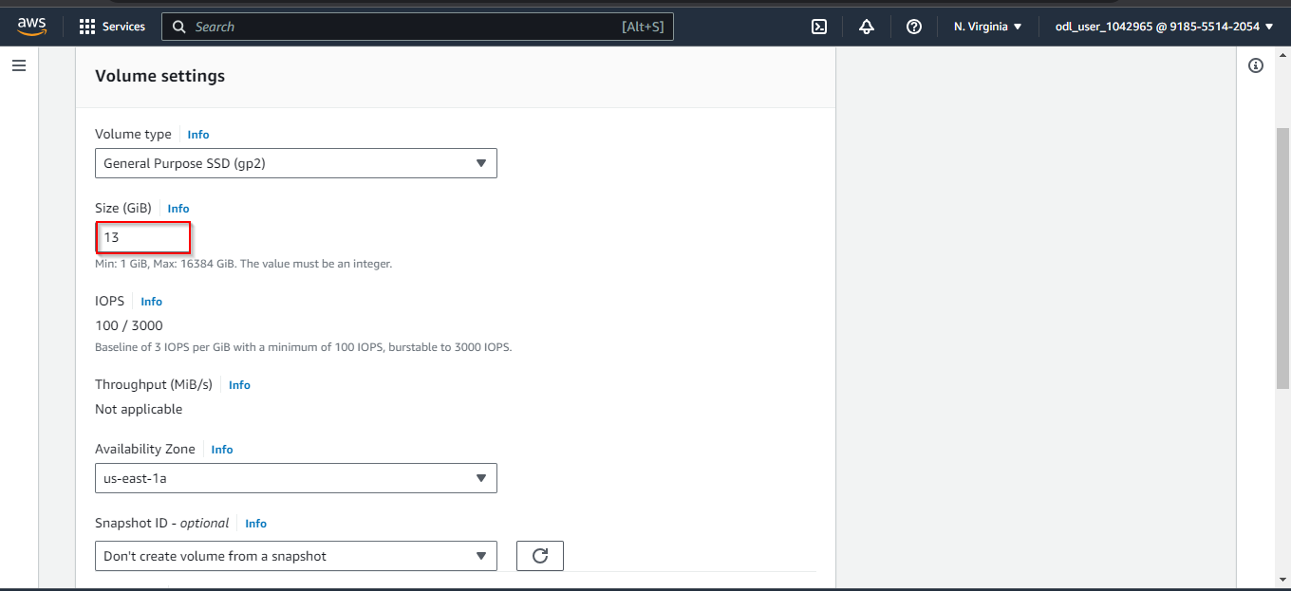

**Note**: The **Availability Zone** should be provided as the same as the EC2 instance created.

1. Click on **Create volume**

1. Click on the edit icon and change the name to **New Volume**

1. Connect to the AWS Linux VM by clicking on **Instances**, selecting the instance, and clicking on the **Connect** button

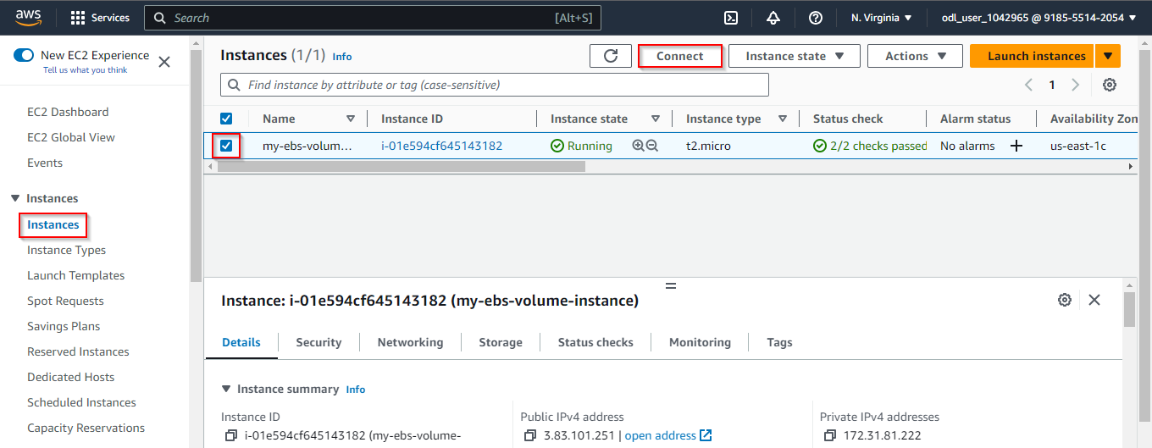

1. Click on the **Connect** button

The EC2 instance was successfully connected to the Amazon Linux VM.

1. Enter the following command to view the **EBS** volumes created:

**lsblk**

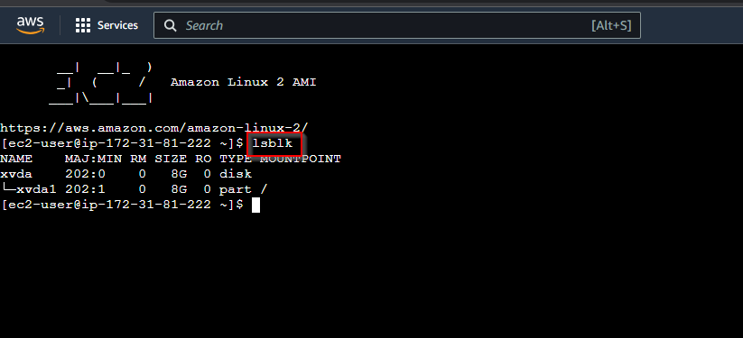

**Step 5:** **Detach the existing volume from the EC2 Instance**

1. Navigate to the instance **my-ebs-volume** and click on **Stop instance** from the **Instance state** tab

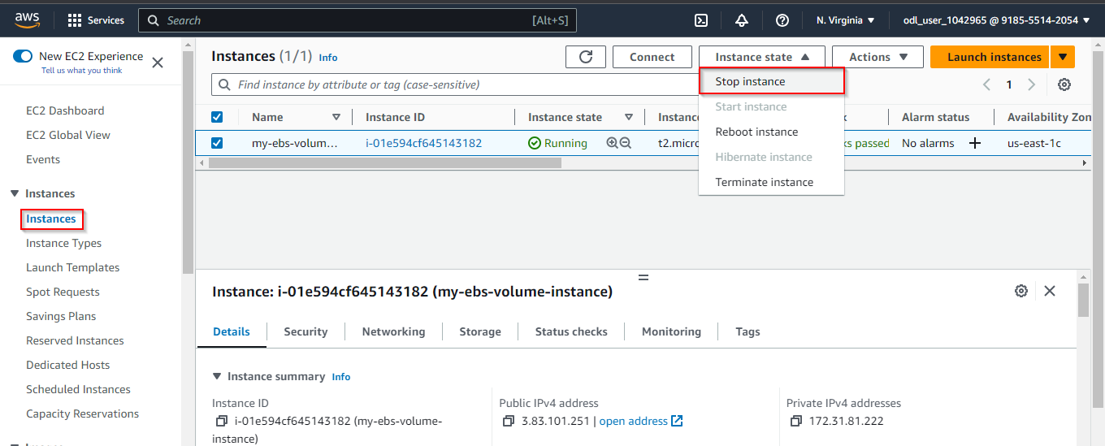

1. Click on the **Stop** button

The instance has been successfully stopped.

1. Navigate to the **Elastic Block Store** and **Volumes**. Now, select the **old volume** checkbox.

1. Under the **Actions** tab, click on **Detach** **volume**

1. Click on **Detach**

The **old volume** has been successfully detached.

1. Start the instance by clicking on the **Instance** tab and then on **Start** **instance**

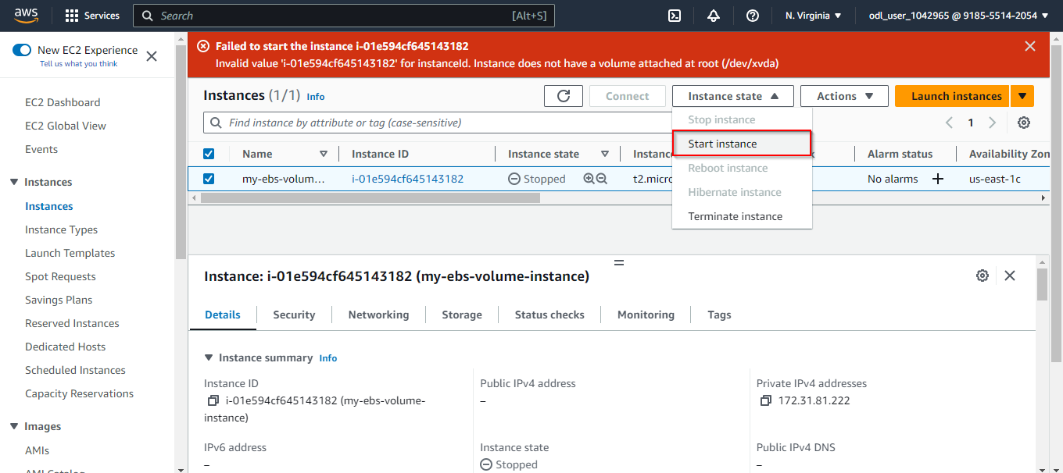

**Note**: It fails to start the instance as there is no volume attached.

**Step 6:** **Attach a new volume to the EC2 Instance**

1. Navigate to the **Volumes** section, select the **New** **volume**, and click on **Attach** **volume** under the **Actions** tab

1. Select the **my-ebs-volume** instance and click on **Attach volume**

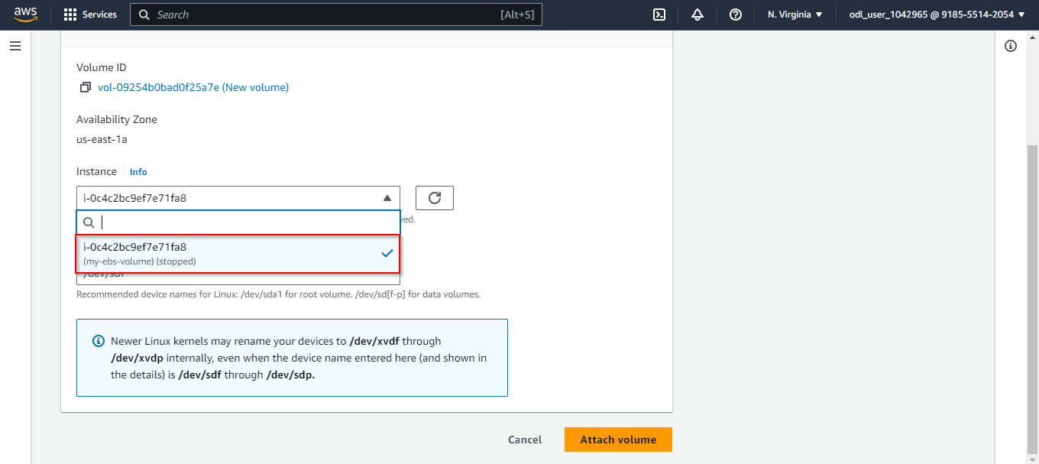

The **New volume** with 13 GiB has been successfully attached.

1. Navigate to the Instance and click on **my-ebs-volume**. Now, click on the **Instance state** and **Start** **instance**

You must use the **us-east-1a** availability zone.

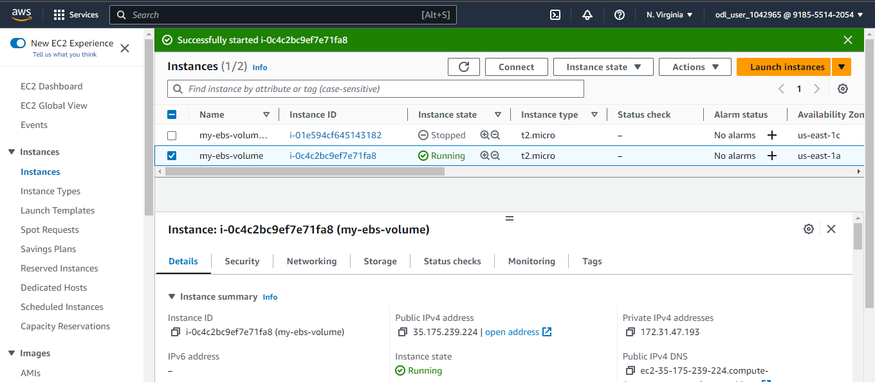

The EC2 Instance has been successfully started after attaching the volume. This attachment and detachment of volumes show the vertical scalability of the Amazon Linux VM.